SAFEGRID-AI: AN EXPLAINABLE MULTI-AGENT SYSTEM FOR DYNAMIC POWER ROUTING
Design and Implementation
Department of Computer Science and Engineering, TKR College of Engineering and Technology (Autonomous)
Batch A13 (CSE-A) · Academic year [ACADEMIC YEAR]
Table 1: Project team
S.No. | Student name | Roll number
1 | DISHA KAUSHAL | 23K91A0563
2 | BOLLAM RAKESH | 23K91A0542
3 | CHINNOLLA RAVINDHAR | 23K91A0554
4 | AFFAN MOHAMMED RAMY | 23K91A0505

Project guide: CHANDRASHEKAR
Chapter and section numbers quoted in the text (for example Section 6.6 or Chapter 8) refer to the full project report, 17.Final Document. Figures and tables in this document are numbered from 1.

1. DESIGN

5.1 Overall System Architecture
The design follows three rules. The model that proposes and the code that decides must be separate. Everything that decides must be deterministic and testable without a language model. And every decision must leave a record that can be checked afterwards. They follow the shielding idea of safe reinforcement learning [12], in which a verified layer sits between a learner and its environment, and the multi-agent view of power systems [8]. The layers are shown below.
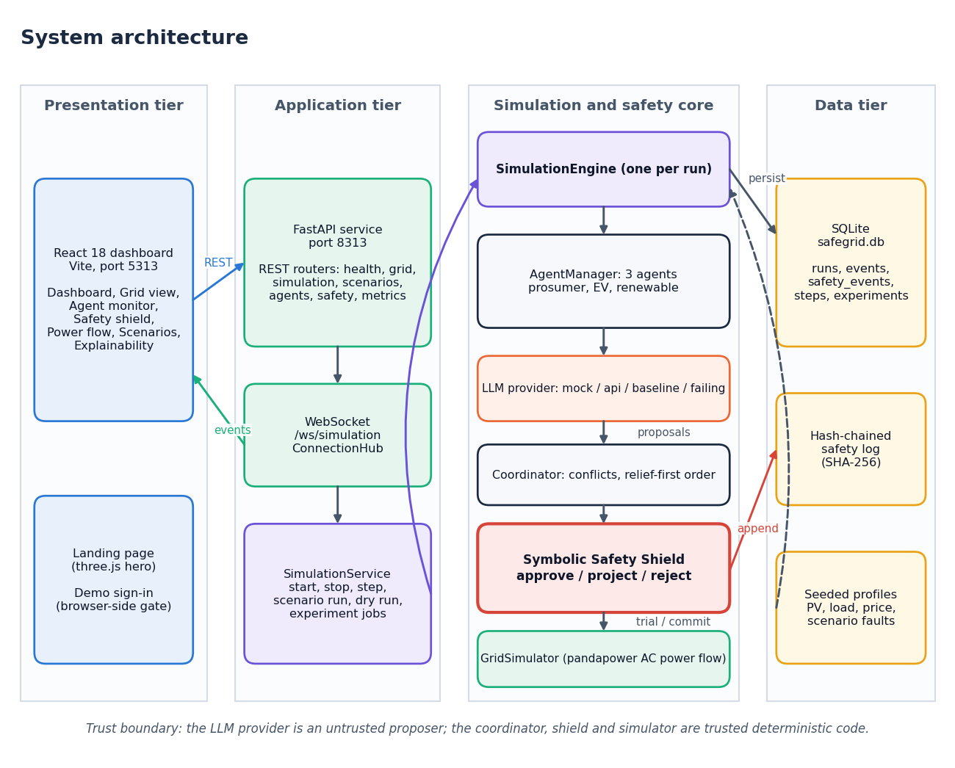
Figure 1: System architecture of SafeGrid-AI
The system has four tiers. The presentation tier is the React 18 console served by Vite on port 5313: a landing page with a three.js hero, a demo sign-in, and seven console screens. The application tier is a FastAPI service on port 8313: REST routers, a WebSocket route (/ws/simulation) that streams events through the ConnectionHub, and SimulationService, which owns the current run, runs scenarios, answers dry-run requests and manages experiment jobs. The simulation and safety core holds one SimulationEngine per run. The engine drives an AgentManager with three agents, whose proposals come from an LLM provider (mock, api, baseline or failing); the coordinator orders the proposals; the Symbolic Safety Shield validates each one; and the GridSimulator runs the pandapower AC power flow for trial and committed states. The data tier is a SQLite file with five tables, the hash-chained safety log, and the seeded profiles and scenario faults. The footnote in the figure states the trust boundary: the LLM provider is an untrusted proposer; the coordinator, shield and simulator are trusted deterministic code.
Two properties of this layout matter. First, the shield package imports nothing from the language-model, agent, simulation or grid packages; a test (test_shield_does_not_import_llm_or_agents) checks this, so model text cannot influence the shield even by accident. Second, the API has no user accounts: it is a single-user research prototype, and the demo sign-in is only a browser gate.

5.2 High-Level Workflow
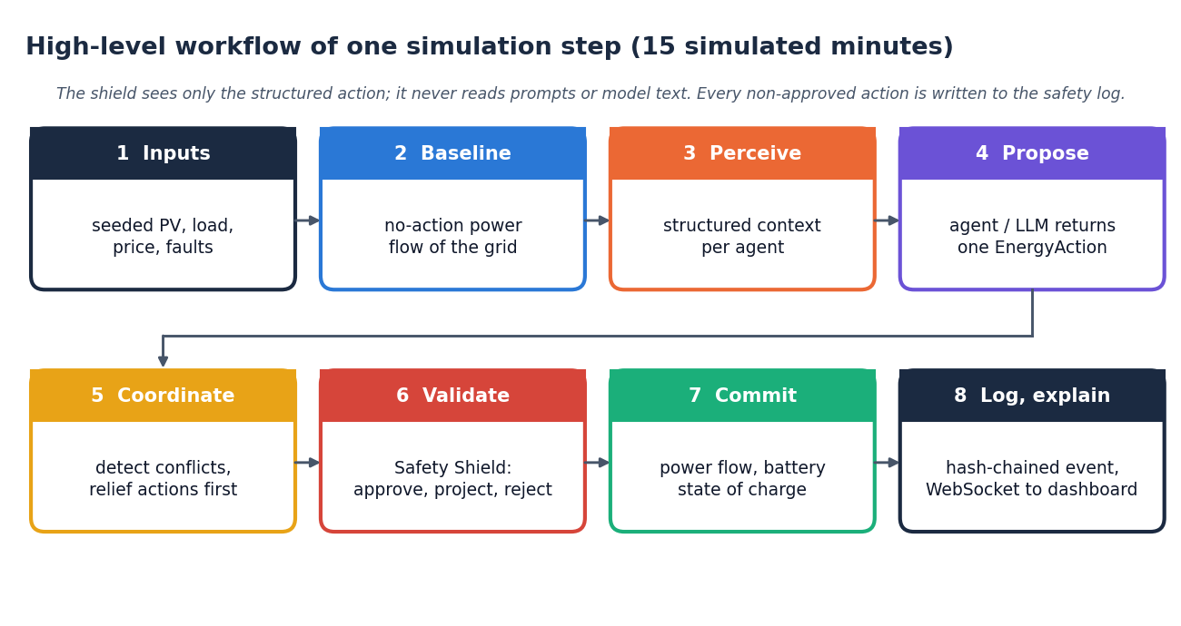
Figure 2: High-level workflow of one simulation step (15 simulated minutes)
One control step has eight stages. (1) Seeded profiles give solar output, household load, price and any scenario fault. (2) A no-action power flow records the grid state if every agent stayed idle; it is the baseline against which later violations are attributed. (3) Each agent perceives a structured context built from its node, its neighbours and the grid limits. (4) Each agent returns one EnergyAction; a provider failure or invalid answer becomes a labelled deterministic fallback. (5) The coordinator detects conflicts and puts relief actions first. (6) The Safety Shield validates the proposals one after another against the cumulative grid state and approves, projects or rejects each. (7) Only the validated set-points are committed: the power flow is run again and battery states of charge are updated. (8) Non-approved decisions are appended to the hash-chained safety log, the step is stored, and events are streamed to the dashboard.
The same stages run for Start (repeated on a timer, streaming events), Step (one pass) and a scenario run to completion. A dry run, POST /api/agents/{id}/decision, validates the agent's current proposal (or an action written by the operator) against the current state with trial power flows; nothing is committed and the run does not advance.

5.3 Data Flow Diagrams

Level 0: context
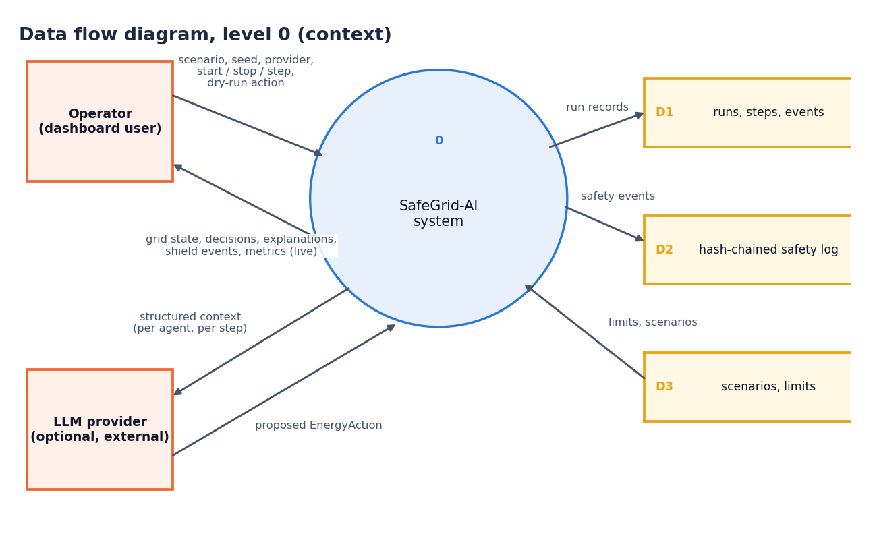
Figure 3: Data flow diagram, level 0 (context diagram)
The context diagram shows SafeGrid-AI as a single process with two external entities. The operator sends the scenario, seed, provider choice, start, stop and step commands and dry-run actions, and receives live grid state, decisions, explanations, shield events and metrics. The optional LLM provider receives the structured context of each agent and returns a proposed EnergyAction. Internally the system writes the run store (runs, steps, events; D1) and the hash-chained safety log (D2), and reads the scenario and constraint configuration (D3).

Level 1
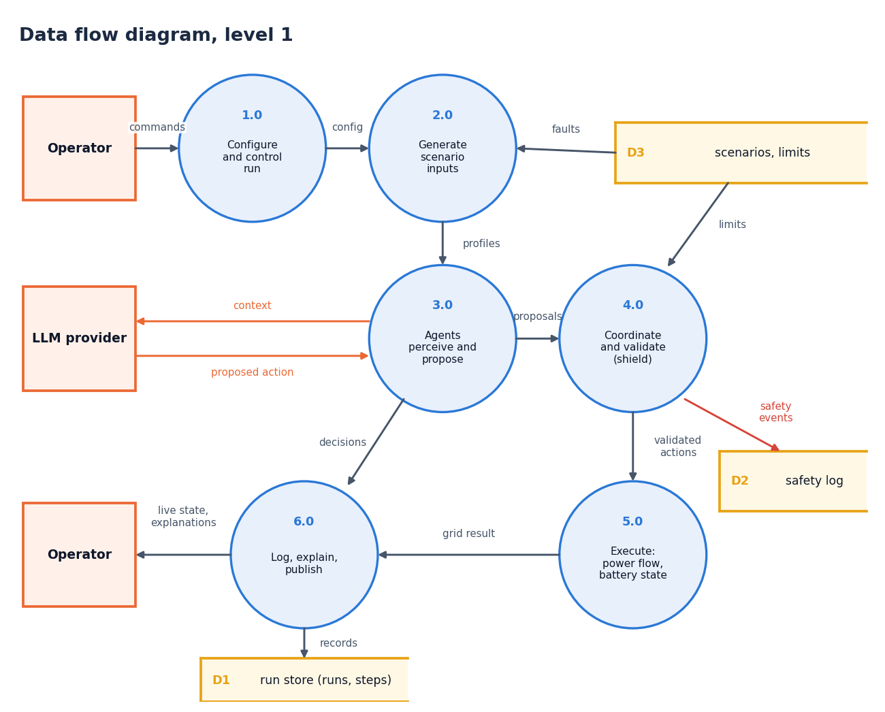
Figure 4: Data flow diagram, level 1
Level 1 splits the system into six processes. Configure and control run (1.0) accepts the operator's commands. Generate scenario inputs (2.0) combines the run configuration with the faults and limits in D3 and produces the seeded profiles. Agents perceive and propose (3.0) exchanges context and proposed actions with the LLM provider. Coordinate and validate (4.0) is the shield: it reads the limits, appends safety events to D2 and passes validated actions on. Execute (5.0) runs the power flow and updates battery states. Log, explain and publish (6.0) writes the run store (D1) and returns live state and explanations to the operator.

Level 2: the shield process
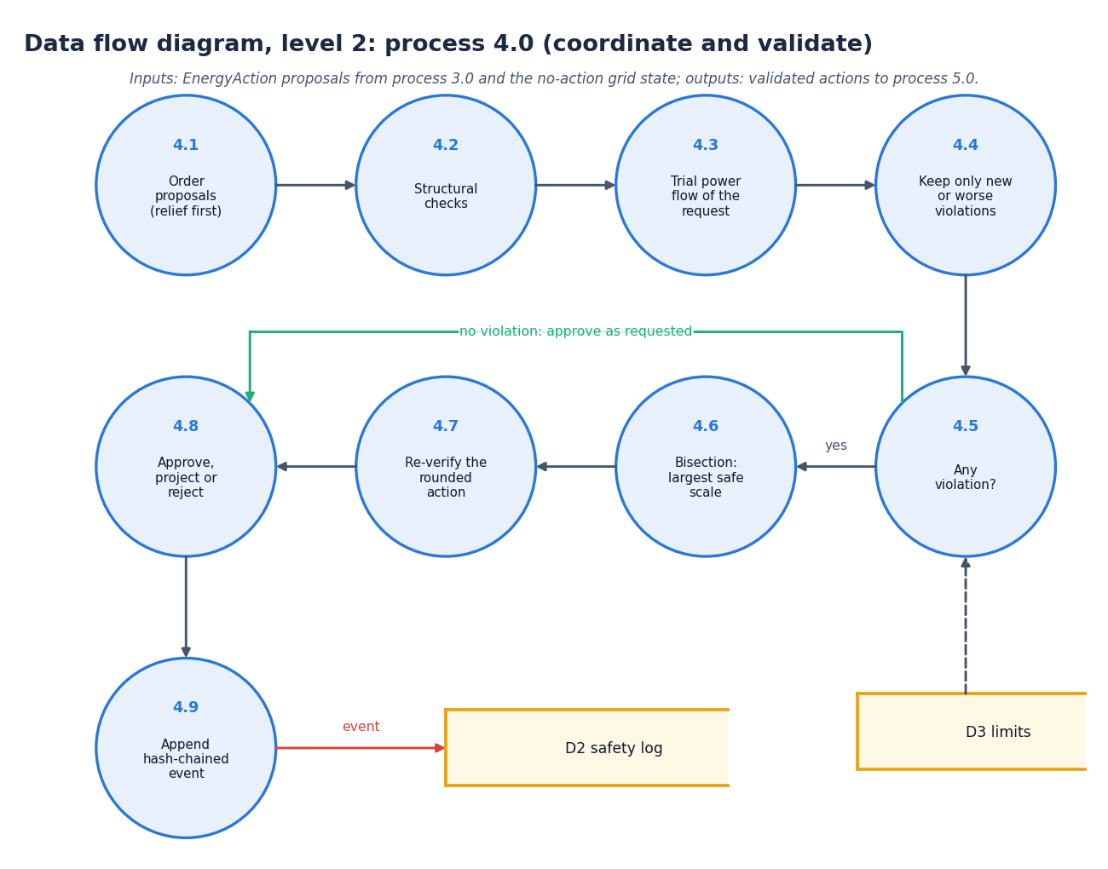
Figure 5: Data flow diagram, level 2: process 4.0 expanded
Level 2 expands the shield process into the steps that SymbolicSafetyShield.evaluate performs. Proposals are first ordered with relief actions first (4.1) and checked structurally (4.2). A trial power flow of the request as proposed (4.3) is compared with the no-action baseline so that only new or worse violations are kept (4.4); the limits come from D3. If there is none (4.5) the action is approved as requested. Otherwise a bisection finds the largest safe scale of the action (4.6), the rounded action is verified again (4.7), the decision is formed as approve, project or reject (4.8), and a hash-chained event is appended to D2 (4.9).

5.4 UML Diagrams

Class diagram
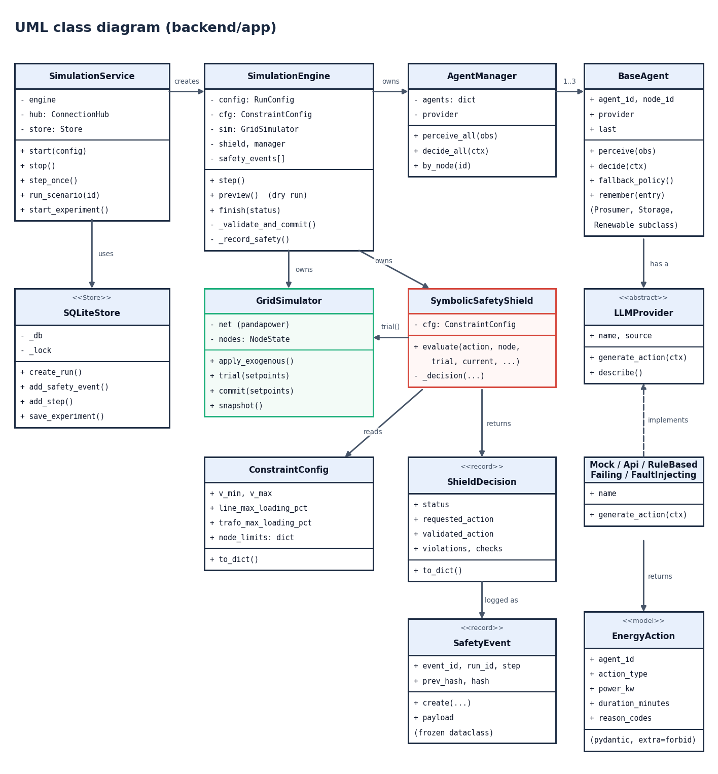
Figure 6: UML class diagram of the backend (backend/app)
SimulationService creates and controls the SimulationEngine and uses the SQLiteStore. The engine owns the AgentManager, the GridSimulator and the SymbolicSafetyShield. The manager holds the agents derived from BaseAgent (the prosumer, storage and renewable subclasses differ only in the extra context they add); each agent has an abstract LLMProvider, implemented by the mock, api, rule-based, failing and fault-injecting providers, which returns an EnergyAction. The shield reads a ConstraintConfig, calls GridSimulator.trial and returns a ShieldDecision; non-approved decisions are logged as SafetyEvent records whose prev_hash and hash fields form the chain.

Sequence diagram
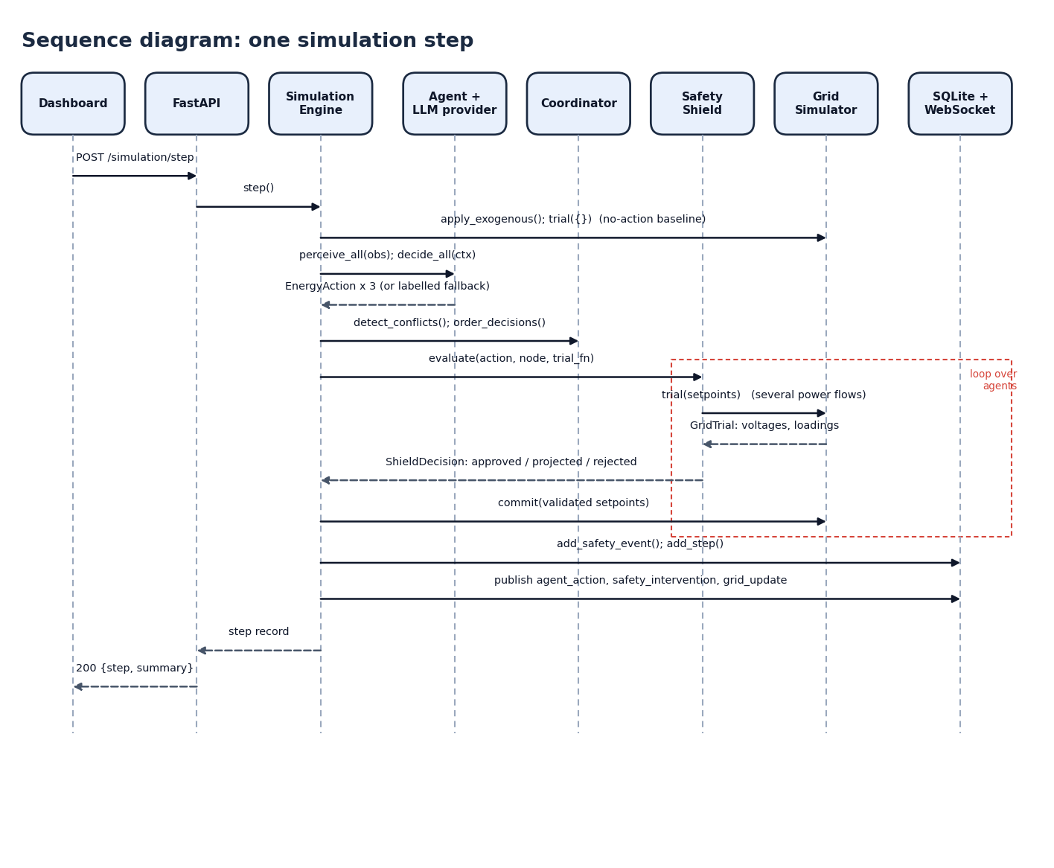
Figure 7: Sequence diagram: one simulation step
The dashboard posts to /api/simulation/step (a live run repeats the sequence in a background task). FastAPI calls step() on the engine, which applies the exogenous inputs, runs the no-action power flow, and calls perceive_all and decide_all on the agents; they return three actions. The engine detects conflicts, orders the proposals and calls evaluate on the shield for each in turn (the dashed frame); the shield calls trial on the grid simulator several times and returns a ShieldDecision. The engine commits the validated set-points, stores the safety events and the step, publishes agent_action, safety_intervention and grid_update events to the WebSocket clients, and returns the step record.

Use-case diagram
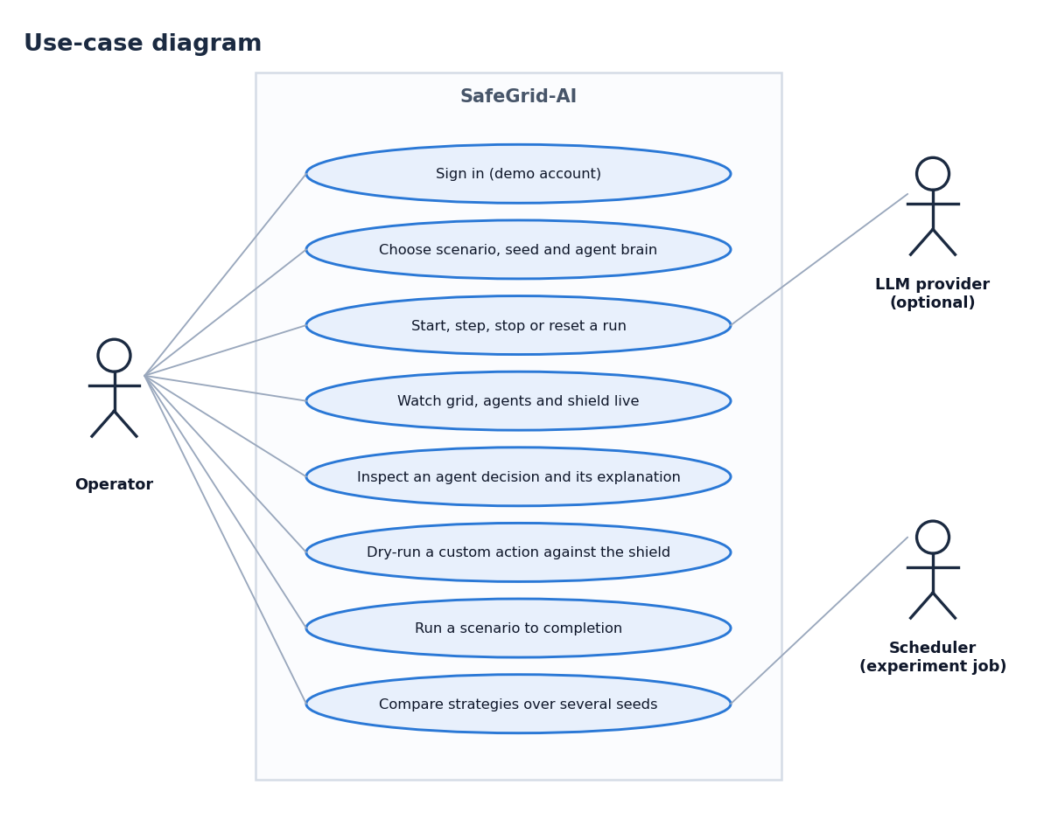
Figure 8: Use-case diagram
The operator can sign in with the demo account, choose a scenario, seed and agent brain, start, step, stop or reset a run, watch the grid, agents and shield live, inspect an agent decision and its explanation, dry-run a custom action against the shield, run a scenario to completion and compare strategies over several seeds. The optional LLM provider takes part in the run use cases by answering each agent's context; the experiment scheduler (a background job inside the service) takes part in the strategy comparison.

5.5 Entity-Relationship Diagram
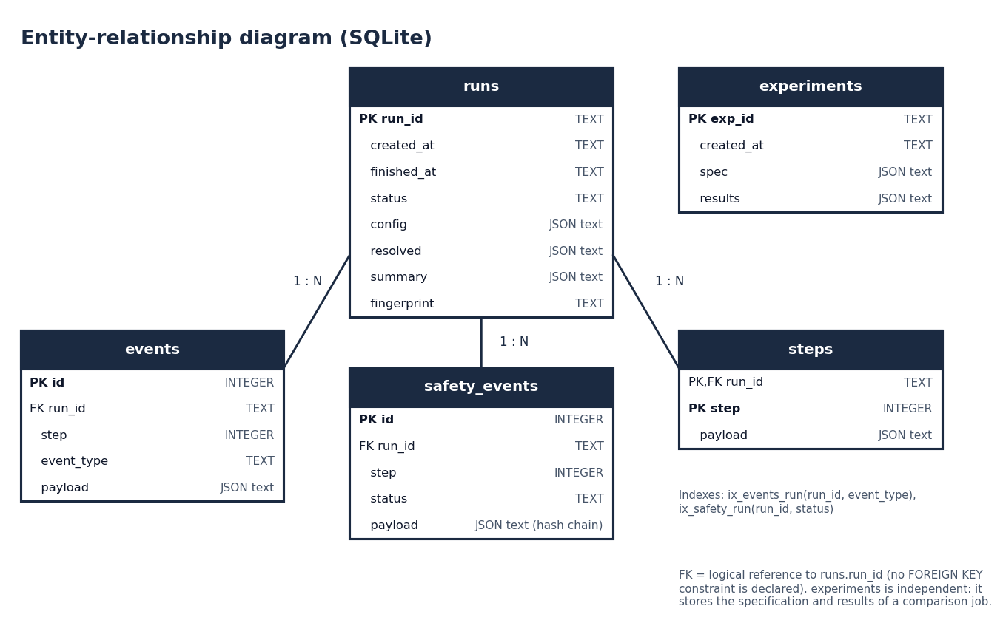
Figure 9: Entity-relationship diagram of the SQLite store
runs holds one row per simulation run, with its configuration, resolved settings, summary and the final hash of the safety chain. events (stream events), safety_events (non-approved decisions with their hash chain) and steps (one row per step) each reference a run by run_id, one run to many rows. experiments is independent: it stores the specification and aggregate results of a strategy comparison. Two indexes speed up the lookups of events and safety events by run.

5.6 Database Schema and Table Descriptions
The store keeps five tables: run configuration and results, the event stream, the safety log, per-step records and strategy comparisons, which is everything the dashboard shows after a reload. Nothing else is persisted: the grid state is rebuilt from the seed and the scenario.
Table 2: Table runs
Column | Type | Constraint | Meaning
run_id | TEXT | PRIMARY KEY | Identifier of the run
created_at | TEXT |  | UTC creation time
finished_at | TEXT |  | UTC finish time (null while running)
status | TEXT |  | idle, running, paused, stopped, completed or failed
config | TEXT (JSON) |  | RunConfig as submitted
resolved | TEXT (JSON) |  | Scenario, steps, time step, seed, provider, constraints used
summary | TEXT (JSON) |  | Final metrics of the run
fingerprint | TEXT |  | Hash of the last safety event (chain head)

Table 3: Table events
Column | Type | Constraint | Meaning
id | INTEGER | PRIMARY KEY AUTOINCREMENT | Row number
run_id | TEXT | indexed with event_type | Run the event belongs to
step | INTEGER |  | Simulation step
event_type | TEXT |  | agent_action, safety_intervention, grid_update, ...
payload | TEXT (JSON) |  | The event as streamed

Table 4: Table safety_events
Column | Type | Constraint | Meaning
id | INTEGER | PRIMARY KEY AUTOINCREMENT | Row number
run_id | TEXT | indexed with status | Run the event belongs to
step | INTEGER |  | Simulation step
status | TEXT |  | projected, rejected (or approved for an anomaly record)
payload | TEXT (JSON) |  | Requested and validated action, violations, corrections, checks, grid before/after, prev_hash, hash

Table 5: Table steps
Column | Type | Constraint | Meaning
run_id | TEXT | PRIMARY KEY (with step) | Run
step | INTEGER | PRIMARY KEY (with run_id) | Simulation step
payload | TEXT (JSON) |  | Full step record: grid snapshot, agent rows, conflicts, counts

Table 6: Table experiments
Column | Type | Constraint | Meaning
exp_id | TEXT | PRIMARY KEY | Identifier of a strategy comparison
created_at | TEXT |  | UTC creation time
spec | TEXT (JSON) |  | Scenarios, seeds, steps, arms, time step
results | TEXT (JSON) |  | Per-run summaries and aggregates

The tables are created by CREATE TABLE IF NOT EXISTS, so a fresh checkout needs no migration, and every statement uses bound parameters. Structured values are stored as JSON text, which keeps the schema stable while the event payloads evolve. The store is a single connection with a lock, adequate for one operator and listed as a limit in Chapter 9.

5.7 Module Architecture
The backend is organised by responsibility. The table below lists the modules with their measured sizes (lines of Python, counted from the source files when this report is built). The backend has 3,117 lines in app/ and 624 lines of tests; the frontend has 6,989 lines of JavaScript, JSX and CSS.
Table 7: Backend modules and their size
Module | Role | Lines
api/, services/ | REST routers, run lifecycle, experiment jobs, WebSocket hub | 438
simulation/engine.py | One run: step loop, validation, metrics, events | 416
simulation/ (other) | Coordinator, scenarios, seeded profiles, strategy comparison, runners | 362
agents/, llm/ | Agents, manager, policies, explanations; provider contract and providers | 544
safety/ | Constraints, validator, projector, shield, hash-chained events | 621
grid/ | pandapower network, power-flow wrappers, GridSimulator | 400
database/, models/, config.py, main.py | SQLite store, EnergyAction and run schemas, settings, entry point | 336
Backend total |  | 3,117

The frontend is a single-page application with one lazy-loaded chunk per page (landing, login, dashboard, grid view, agent monitor, safety shield, power flow, scenarios, explainability), so three.js is fetched only for the landing page. State is kept in a SimulationProvider that wraps the REST and WebSocket clients; the pages are views of that state.

5.8 Shield Decision Workflow
The next three figures show the core algorithm, the grid it protects and the audit mechanism, the parts of the design that Chapter 8 tests directly.
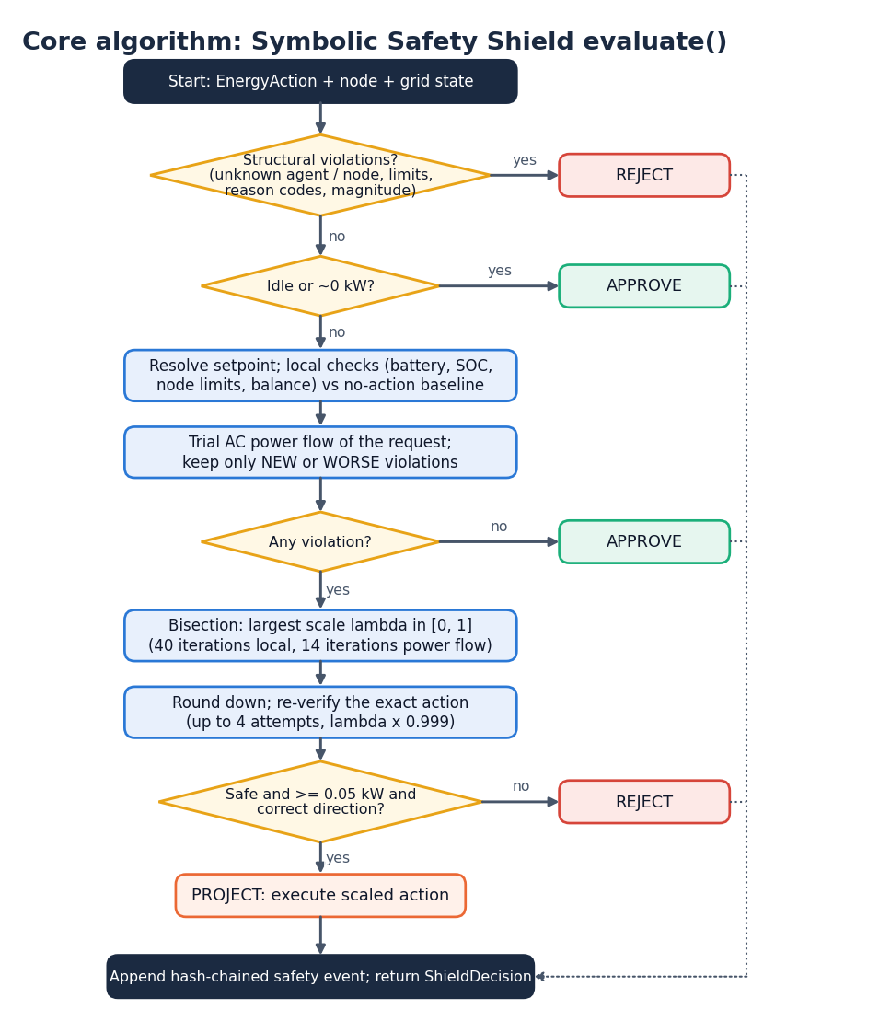
Figure 10: Core algorithm: Symbolic Safety Shield evaluate()
The flowchart follows the code in safety/shield.py. A structural violation (unknown agent or node, an agent acting on a node it does not own, a non-finite, negative or implausible power) rejects the action at once; an idle or zero-power action is approved. Otherwise the action becomes a physical set-point, the local checks (battery, state of charge, node limits, balance) and one trial power flow are run, and only violations that are new or worse than the no-action state count. With none, the action is approved. With some, a bisection (40 iterations for local limits, 14 for power-flow limits) finds the largest safe scale; the rounded action is re-verified up to four times; and the action is rejected if nothing safe remains, if the safe part is below 0.05 kW, or if an import or export target would change direction. Otherwise the scaled action is executed as a projection. Every outcome other than approval is appended to the safety log.
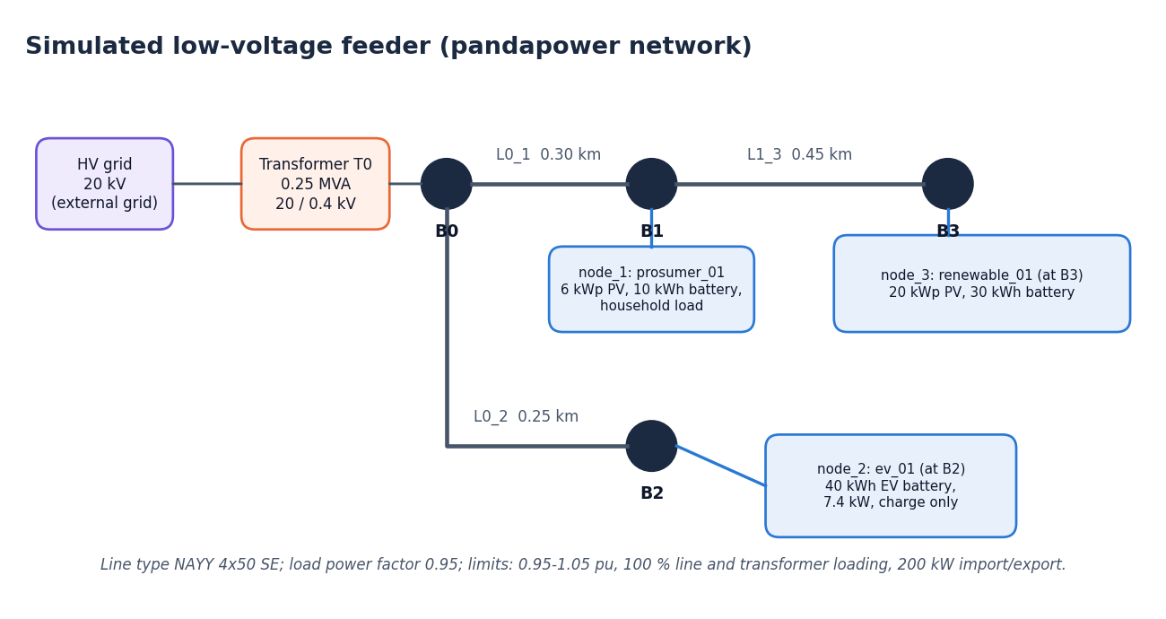
Figure 11: Simulated low-voltage feeder (pandapower network)
The simulated grid is a 20 kV external grid feeding a 0.25 MVA 20/0.4 kV transformer (T0) at bus B0. Line L0_1 (0.30 km) connects B0 to B1, where node_1, the residential prosumer (6 kWp PV, 10 kWh battery), is attached; line L1_3 (0.45 km) continues to B3, node_3, the renewable prosumer (20 kWp PV, 30 kWh battery); line L0_2 (0.25 km) connects B0 to B2, node_2, the EV (40 kWh battery, 7.4 kW, charge only). All lines are NAYY 4x50 SE cable and the load power factor is 0.95.
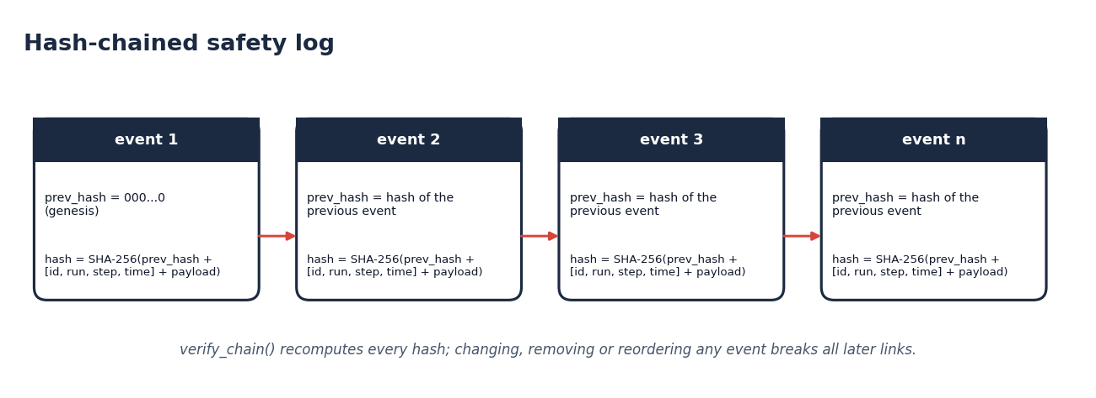
Figure 12: Hash-chained safety log
Each safety event stores the hash of the previous event (a string of zeros for the first) and its own SHA-256 hash over the previous hash, the identifiers [event id, run, step, simulated time] and the canonical payload. verify_chain recomputes every hash, so changing, removing or reordering any event breaks all later links. The wall-clock time is stored but excluded from the hash so that reruns are comparable.
Design limits. The feeder is small by choice: one step still costs several trial power flows, and the experiment of Chapter 8 needed about ten minutes for 63 runs. The shield checks actions against the model it is given; if the simulated network differs from a real one, the guarantee does not carry over. Grid-Agent [2] also validates plans by sandboxed execution, which likewise depends on the model that is executed. This limitation is stated again in Chapters 8 and 9.

2. IMPLEMENTATION

6.10 Application Architecture and Implementation
Backend. The backend is a FastAPI application (app/main.py) with five routers and one WebSocket route. SimulationService owns the current SimulationEngine and the background task that runs it, and implements start, stop, reset, single step, scenario run and the background experiment jobs, which are stored when they finish. The engine's step is asynchronous: the agents are asked concurrently, and the CPU-bound part (shield, trial power flows and commit) runs in a worker thread so that the API stays responsive. The GridSimulator guards the shared pandapower network with a re-entrant lock because API dry runs may arrive during a run. The ConnectionHub broadcasts events to the browsers and drops a client whose send fails, so a broken client can never stop the simulation.
Persistence. SQLiteStore writes runs, stream events, safety events, per-step records and experiments (Chapter 5). The head of each run's hash chain is stored as the run's fingerprint, so a stored run can be checked later.
Frontend. The console is a React 18 application built with Vite, in the kit named "Depth Studio"; the three.js hero of the landing page is replaced by a static image for users who prefer reduced motion. A SimulationProvider keeps the REST and WebSocket state; the run bar on every screen selects the scenario, agent brain, seed and playback speed and offers Start, Resume, Step, Stop and Reset. The charts are drawn with Recharts and the layout adapts from 360 to 1440 pixels, with the sidebar becoming a drawer on narrow screens.

6.11 API Design
The REST API is described by FastAPI's OpenAPI page at /docs. Requests and responses are validated with Pydantic models (RunConfig, DecisionRequest, ExperimentRequest, EnergyAction). Errors use standard codes: 404 for an unknown scenario, agent or run, 409 when the run is in the wrong state, 422 for an invalid body.
Table 8: API endpoints
Method | Path | Purpose
GET | /api/health | Service, provider and pandapower status
GET | /api/grid/state, /api/grid/topology | Current grid snapshot; nodes, edges and devices for the diagram
POST | /api/simulation/start?resume=, /stop, /reset, /step | Run control (409 if already running or finished)
GET | /api/simulation/status | Status, step, provider
GET | /api/scenarios | The seven scenario definitions
POST | /api/scenarios/{id}/run | Run a scenario to completion and return its summary
GET | /api/agents, /api/agents/{id} | Agent cards; one agent's history and latest decision
POST | /api/agents/{id}/decision | Dry run: validate the agent's proposal or an operator-written action; nothing is applied
GET | /api/events | Stream events of the run, filterable by type
GET | /api/safety/events, /api/safety/constraints | Hash-chained events with chain validity; active limits
GET | /api/metrics, /api/runs (+ /{id}, /{id}/steps) | Summary and per-step series; stored runs
POST / GET | /api/experiments/run, /api/experiments, /api/experiments/{id} | Strategy comparison jobs and stored results
WebSocket | /ws/simulation | Event frames: connected, simulation_started, agent_action, safety_intervention, conflict_detected, grid_update, simulation_complete, simulation_stopped, simulation_error

RunConfig carries everything needed to reproduce a run: scenario, seed, steps, time step, provider, unsafe rate, playback delay, constraint overrides, initial states of charge, agent options, whether faults are injected, and whether the shield is enabled. The last field exists for the unshielded ablation arm of the experiment.

6.12 Security, Privacy and Error Handling
• Untrusted model output. The model answers only through one tool call whose arguments must validate against EnergyAction; the agent identity is set by the system; nothing from the model is executed, evaluated, or used as SQL, a shell command or a file path.
• Allow-list and bounds. Only seven action types are accepted; numbers must be finite and bounded; reason codes match a fixed pattern; unknown fields are rejected.
• Database. All statements use bound parameters; JSON is stored as text.
• Secrets. The API key and model name come from environment variables or an untracked .env file; no secret is in the code or in a commit; /api/health reports only whether an LLM is configured.
• Network. Allowed browser origins are configurable (CORS_ORIGINS); credentials are not sent; the development server proxies /api and /ws.
• Failure handling. Provider failure becomes a labelled fallback; a non-converging power flow rejects the action; WebSocket errors are isolated per client; a failed experiment job records its error.
• Privacy. The system handles no personal data: all inputs are synthetic.
What is not secured. The API has no authentication or rate limiting, and the SQLite store has no access control. The system is a single-user research prototype and must not be exposed to an untrusted network as it is.

6.13 Installation and Execution
Everything lives in one folder, safegrid-ai/, with the API on port 8313 and the console on port 5313 (both configurable in .env). On Windows, `run.bat` checks for Python 3.10 or newer and Node.js 18 or newer, creates backend\.venv, installs backend\requirements.txt (FastAPI, uvicorn, pydantic, pandapower, numpy, pandas, scipy, httpx, pytest), creates backend\.env from the example (mock provider, no key needed), installs the frontend packages, starts the API and the Vite console, and opens the browser. The steps are written out in docs/03_HOW_TO_RUN.md and in Appendix B.
To use a real language model, set LLM_PROVIDER=api, LLM_API_KEY and LLM_MODEL in backend\.env and choose "Real LLM (API)" as the agent brain. This path was implemented but was not run against a live model for this report; without a key the agents use the labelled fallback policy.
The checks that accompany the code are the 55 backend test functions (safety 22, agents 12, simulation 11, grid 6, API 4), the 20-check scripts/smoke_test.py that exercises the running API, and a production build of the frontend. The results of these checks, including the three that do not pass, are given in Chapter 7.

3. KEY CODE WALK-THROUGHS
This section walks through the five pieces of code that carry the design. Excerpts are copied from backend/app and shortened only by removing blank lines and comments of no importance.

3.1 The shield's decision procedure (`safety/shield.py`)
SymbolicSafetyShield.evaluate has four stages. It first applies structural checks, then approves an idle action at once, then evaluates the request exactly as proposed with local checks and a trial power flow, and finally, only if that finds a violation, projects the request.
# 1. structural / sanity checks -> reject
sv = validator.structural_violations(action, node, lim, cfg, known_agents, known_nodes)
if sv:
return self._decision(ShieldStatus.REJECTED, action, None, sv, [], Setpoint(), 0.0, current, current, False)

# 3. evaluate the request exactly as proposed
v_local = local_new(sp_req)
v_grid = []
trial_req = None
if not v_local:
trial_req = trial(sp_req)
v_grid = grid_new(trial_req)
violations = v_local + v_grid
if not violations:
... # APPROVED, with the duration aligned to the step

The cheap local checks (battery, node limits, balance) run first, and the expensive trial power flow runs only when they pass. This ordering is why a rejected absurd request costs a median of 36.6 ms while a projected one costs 230.0 ms in the latency table.

3.2 Projection by bisection (`safety/projector.py`)
def bisect_max(is_safe, hi=1.0, iters=30):
"""Largest lam <= hi with is_safe(lam), assuming safety is monotone in lam. Returns 0.0 if none."""
if is_safe(hi):
return hi
if not is_safe(0.0):
return 0.0
lo, up = 0.0, hi
for _ in range(iters):
mid = 0.5 * (lo + up)
if is_safe(mid):
lo = mid
else:
up = mid
return lo

is_safe(lam) scales the physical effect of the action by lam and asks whether the scaled action creates any new or worse violation. The shield first bisects over the cheap local limits (40 iterations) and then over the power-flow limits (14 iterations). The monotonicity assumption in the docstring is the honest weak point of the method: if a smaller action could be less safe, the bisection could return an unsafe value, which is why the shield then re-verifies the exact rounded action up to four times, multiplying lam by 0.999 each time, and rejects any result below 0.05 kW.

3.3 Attribution of violations (`safety/validator.py`)
def new_violations(after, before, tol=1e-4):
"""Violations attributable to the action: new, or pre-existing but made worse."""
prior = {v.key(): v.excess for v in before}
return [v for v in after if v.key() not in prior or v.excess > prior[v.key()] + tol]

before is the violation list of the grid with every agent idle (base_grid) and after is the list after the trial. A violation that existed before survives only if its excess has grown by more than the tolerance. The same function defines the metric violations_caused_by_actions in the engine, so the shield and the evaluation use one definition.

3.4 Ordering of proposals (`simulation/coordinator.py`)
RELIEF = {"idle", "curtail_generation", "shift_load"}

def order_decisions(decisions, step):
"""Relief actions first (they can only help), then rotate the rest for fairness."""
ds = list(decisions)
if ds:
k = step % len(ds)
ds = ds[k:] + ds[:k]
return sorted(ds, key=lambda d: 0 if d.action.action_type in RELIEF else 1)

The coordinator never edits an action. It rotates the starting agent each step so that no agent always sees the grid first, and then moves relief actions to the front, because sorting is stable and relief actions can only help. The shield validates the proposals in this order against the cumulative state, so a later proposal sees the effect of earlier ones. detect_conflicts reports PEER_MISMATCH, TARGET_CONTENTION and SHARED_FEEDER for the log and the dashboard; 241 conflicts were reported across the 21 shielded runs.

3.5 The tamper-evident log (`safety/events.py`)
@staticmethod
def create(event_id, run_id, step, sim_time, wall_time, payload, prev_hash):
body = _canonical(payload)
digest = hashlib.sha256((prev_hash + _canonical([event_id, run_id, step, sim_time]) + body).encode()).hexdigest()
return SafetyEvent(event_id, run_id, step, sim_time, wall_time, body, prev_hash, digest)

def verify_chain(events):
prev = GENESIS
for e in events:
expect = hashlib.sha256((prev + _canonical([e.event_id, e.run_id, e.step, e.sim_time]) + e.payload_json).encode()).hexdigest()
if e.prev_hash != prev or e.hash != expect:
return False
prev = e.hash
return True

Each event stores the hash of the one before it, and its own hash covers that value, the event identity and a canonical (sorted-key, compact) JSON payload. The wall-clock time is stored but left out of the hash so that two runs with the same seed produce the same chain. Editing the payload of one event, removing one or reordering them changes a hash and breaks every later link; verify_chain recomputes them all. The log is tamper-evident, not tamper-proof: anyone who can rewrite the whole chain can also recompute it, so the head hash would have to be stored elsewhere to detect that.

3.6 One step of the engine (`simulation/engine.py`)
SimulationEngine.step is the place where the pieces meet. It applies the seeded inputs to the simulator, takes a no-action baseline with a trial power flow, builds an observation, lets the agent manager perceive and decide concurrently, asks the coordinator for conflicts and an order, and then hands the validation and commit to a worker thread because it is CPU-bound.
contexts = await self.manager.perceive_all(obs)
decisions = await self.manager.decide_all(contexts)
conflicts = coordinator.detect_conflicts(decisions)
ordered = coordinator.order_decisions(decisions, i)

results, raw_viol, final_trial, stats = await asyncio.to_thread(
self._validate_and_commit, decisions, ordered, current)

Inside _validate_and_commit the engine first computes the counterfactual: it resolves every raw proposal to a set-point, runs one trial power flow with all of them applied, and records the violations (raw_viol). This is the number reported as violations the raw proposals would cause. It then validates the ordered proposals one by one, each against the cumulative set-points accepted so far, and finally commits the accepted set-points once. In the ablation arm the same function applies the proposals as requested without the shield, so the two arms differ in one branch.

3.7 Provider failure becomes a labelled fallback (`agents/base_agent.py`)
try:
action, source = await asyncio.wait_for(self.provider.generate(ctx), timeout=self.timeout_s)
except Exception as e: # any provider failure -> labelled deterministic fallback (still shielded)
reason = f"{type(e).__name__}: {str(e)[:160]}"
action, source = self.fallback_policy(ctx), "fallback"

Time-outs, unreachable services, unconfigured keys and schema-invalid outputs all end in the same place: a deterministic cost-aware decision tagged fallback, with the reason kept for the log. The fallback decision is passed to the shield like any other proposal, so a model outage can neither stop the grid agents nor bypass validation. In the experiment the fallback rate is 0.2 %, which is the one deliberately malformed output injected by the unsafe_ai_action scenario.

4. IMPLEMENTATION DECISIONS AND THEIR REASONS
Table 9: Implementation decisions and their reasons
Decision | Reason | Cost accepted
Separate proposer and validator behind a closed schema | The model may be wrong or hostile; the layer that stops it must not depend on it. The schema forbids extra fields and non-finite numbers, and a test enforces the import isolation. | Every proposal must be expressible as one of seven action types
Project instead of veto | The agent's intent is usually sensible at a smaller size; 237 of 1,512 proposals were kept this way. | Bisection needs several trial power flows; assumes monotone safety
Full AC power flow in the loop (pandapower) | Voltage and line limits depend on the whole network; a lumped approximation would miss the effects the shield exists to catch [11]. | About 0.1 s of compute per step; the shielded step time is 347.8 ms
Attribute violations against the idle baseline | Separates what an action causes from stress the scenario creates, and lets the shield accept actions that relieve a violated grid. | A violation that was already present is not removed by design
Relief-first, rotating order | Relief actions cannot harm, and rotation avoids a fixed favourite among the agents. | Order still matters: later proposals may be projected harder
Structured explanations, no chain-of-thought | Model-written rationales are not faithful accounts of behaviour [17]; structured inputs and factors can be checked. | Explanations are less fluent than free text
Deterministic, seeded mock provider | Reproducible experiments and tests without an API key; the same seed gives the same totals. | Results measure the shield and coordination, not language-model quality
Labelled fallback decision | Any provider failure, time-out or invalid output becomes a deterministic decision tagged fallback and is still shielded, so a model outage cannot stop or endanger the grid. | Fallback quality is that of a simple cost-aware heuristic
SQLite with a hash-chained log | No server to install; the chain makes edits detectable [20]. | Single-writer database; the head hash is not stored elsewhere
FastAPI with REST and one WebSocket | Typed requests (pydantic), automatic validation (422 for unknown fields), and a single stream for live events. | No authentication in the prototype
React console with a demo sign-in | Gives a reviewable operator view; the sign-in only gates the demonstration. | The gate is browser-side and not a security boundary
15-minute step | Matches typical metering and tariff intervals and keeps a quasi-static model reasonable. | Fast dynamics are not represented

Two decisions are worth stating in more detail because they are easy to get wrong. First, import and export are treated as net exchange targets and not as battery commands: asking to export 5 kW means that the node's connection point should carry 5 kW outward, and the battery covers the difference between that target and the node's own load and solar balance. That is why a request to export 3 kW from a node that can only import is rejected as DIRECTION_UNATTAINABLE; no amount of scaling turns an import into an export. Second, the shield never trusts the arithmetic of the proposal. It does not read the agent's stated confidence or reason codes when deciding; they are stored for the audit trail only.

Alternatives considered
• A validation agent instead of a rule layer. A second language model that checks the first was not chosen, because a safety layer built from the same kind of component shares its failure modes and cannot be tested to a fixed expectation. A deterministic checker can be unit-tested with hand-written cases.
• A linearised power-flow check. A DC or sensitivity-based approximation is faster, but voltage limits at the end of a weak feeder are exactly where the approximation is poorest; the exact AC trial was kept and its cost accepted.
• Rejecting every unsafe proposal. This is the simplest rule and would have rejected 350 proposals, 237 of which were only too large. Projection kept most of their value.
• Storing model rationales for explanation. Rejected on grounds of faithfulness and of cost; structured factors were enough to explain each decision and are checkable.

